Product Requirement Document (PRD)
Medicine Manager Platform — Multi-Site Nuclear Medicine Operational Suite
Project Name: | Medicine Manager Platform | Document Target: | Hackathon Presentation & Operational Blueprint
Document Source: | Operational Specification Manual | Version: | 1.2 (Visual Workflows Integrated)

1. Executive Summary
Medicine Manager is an enterprise-grade operational platform engineered to govern nuclear medicine inventory (specifically radiopharmaceutical kits) and radio-isotope production across multi-site hospital networks. The system ensures absolute end-to-end traceability, audit readiness, real-time status transitions, and automated regulatory compliance alerts extending from central warehouses to hospital operating suites.
Core Vision: The primary goal for this platform is to enforce real-time quarantine, uncompromised audit readiness, and strict operational isolation between machine synthesis and inventory consumption.

2. Target Audience & User Roles
Role | Operational Focus | Primary Responsibilities
System Admin | Network-Wide Oversight | Enterprise monitoring, global audit logs, site/user provisioning, cross-site analytical reporting, and compliance verification.
Warehouse Manager | Supply & Logistics | Stock intake, global unique Kit ID assignments, hospital dispatching, stock transfers, and defect/component resolution.
Hospital Manager | Operations & Usage | Receiving verification, daily patient summary logs, kit run consumption, machine run entry, and downtime reporting.

3. Core Workflows & Visual Architecture

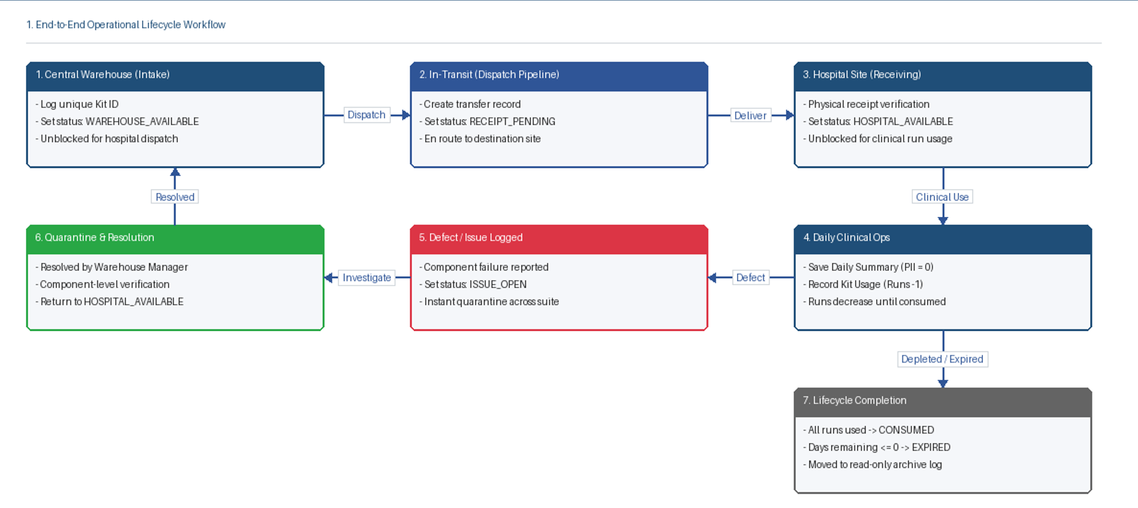
3.1 End-to-End Operational Lifecycle Workflow Diagram

Stage | Location / Domain | Workflow Description
Stage 1: Intake & Stocking | Central Warehouse | Warehouse receives stock, generates a globally unique Kit ID, and sets status to WAREHOUSE_AVAILABLE.
Stage 2: Dispatch & Transit | Dispatch Pipeline | Warehouse creates Transfer order. Kit status shifts to RECEIPT_PENDING while in transit.
Stage 3: Receiving & Stocking | Hospital Site | Hospital Manager performs physical inspection and confirms receipt. Status shifts to HOSPITAL_AVAILABLE.
Stage 4: Daily Operation | Clinical Suite | Daily summary created (patient counts logged). Kit usage is recorded inside summary, reducing available runs until fully consumed.
Stage 5: Defect & Quarantine | Defect Workflow | If component defect is reported, kit transitions to ISSUE_OPEN and is locked from all clinical runs until fully resolved.

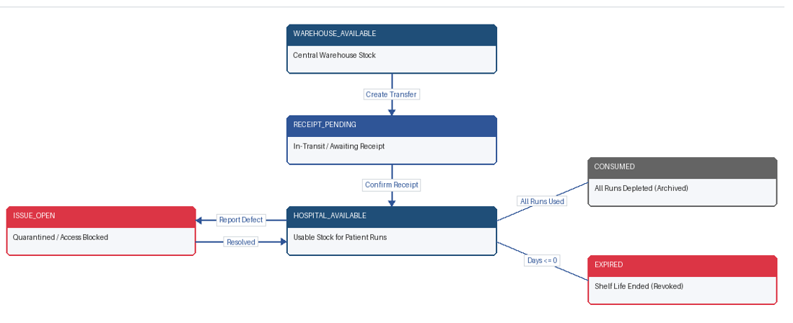
3.2 Status State Transition Model Diagram

Status Enum | Scope | Description & Operational Effect
WAREHOUSE_AVAILABLE | Warehouse | Kit logged and physically stored in central warehouse stock; available for hospital dispatch.
RECEIPT_PENDING | In-Transit | Dispatched to target hospital; awaiting physical delivery verification by Hospital Manager.
HOSPITAL_AVAILABLE | Hospital Site | Physically verified at hospital site; unblocked for active clinical usage.
ISSUE_OPEN | Quarantine | Defect flagged; kit is quarantined and completely blocked across all patient usage screens.
CONSUMED | Historical | All available runs have been depleted; archived as read-only historical record.
EXPIRED | Historical | Kit reached <= 0 days shelf-life; automatically revoked from usable inventory.

4. Detailed Functional Requirements

Module A: Inventory & Transfer Pipeline
- Batch Dispatch & Partial Receiving: Transfers support single or multi-kit movements. If only a subset of kits is physically accepted, the transfer remains in "Partially Received" status until all individual Kit IDs are confirmed by the receiving Hospital Manager.
- Component Defect Resolution Protocol:
  - Defect flagging (e.g., cassette, filter failure) instantly converts status to ISSUE_OPEN, quarantining the entire kit.
  - Component-Level Resolution: Each defective component must be resolved individually by the Warehouse Manager. The kit remains locked until ALL sub-components are marked resolved.
  - Non-Consumption Rule: Reporting a defective component does NOT automatically reduce available kit runs.

Module B: Daily Operations & Functional Isolation
- Daily Summary (Kit Usage Context):
  - Aggregate patient counts recorded daily without logging any personally identifiable information (PII).
  - Kit run consumption is recorded EXCLUSIVELY inside an existing Daily Summary context.
- Production Runs (Machine Synthesis Isolation):
  - Independent machine synthesis logging for ABT and TRASIS systems.
  - Critical Architectural Rule: Production run entries must NEVER contain a Kit ID field.
  - Duplication Constraint: Machine run numbers cannot be duplicated for the same date, hospital, and machine type.

Module C: Expiry & System Audits
- Automated Expiry Escalation Engine:
  - 31–60 Days Remaining: Early Warning Alert.
  - 8–30 Days Remaining: Expiry Warning Alert.
  - 1–7 Days Remaining: Urgent Warning Alert.
  - <= 0 Days Remaining: Expired. Triggers mandatory "Mark as Expired" action and revokes usable stock availability.
- Dual-Timestamp Audit Log:
  - Every transactional event captures both 'Event Date' (when activity actually occurred) and 'Created At' (system timestamp).
  - Any mismatch identifies a Backdated Entry, automatically flagging the record for administrative review.

5. Analytics & Reporting Matrix
Report Type | Data Inputs | Key Output Metrics
Production Performance | ABT & TRASIS Production Logs | Yield in mCi, activity lost, run outcome counts, and success/failure trends (strictly separated per machine).
Kit Usage History | Daily Summary Consumption Logs | Historical run usage per Kit ID, lot tracking, consumption velocity (Read-Only analytics view).
Downtime & Operational Risk | Hospital Downtime Logs | Equipment outages, total downtime duration (minutes), root cause categories, and site performance impact.
Compliance Audit Log | System Event Bus | Immutable user action trails, backdated flags, site configuration logs, and administrative overrides.

